Tour name: 8-Day Ultimate Journey Through Turkmenistan: Civilizations, Deserts & Hidden Wonders
Tour Description:
This 8-day journey offers an in-depth exploration of Turkmenistan’s rich contrasts, from the white-marble grandeur of Ashgabat and the dramatic flames of the Darvaza Gas Crater to the ancient mysteries of Margiana and the striking western landscapes of Yangykala Canyons. Combining archaeology, desert adventure, mountain culture, and modern city landmarks, this itinerary is designed for travelers seeking a deeper and more diverse experience of Turkmenistan.
Starts at: Ashgabat
Ends at: Ashgabat
Please note: The starting and ending points of the itinerary may be adjusted depending on the client’s request, logistics, and tour format.
Group size: 3+
Days: 8
Price: From 1420 USD per person
Pricing note: The tour price depends on the number of participants. The more people join the tour, the lower the price per person will be.
Tour itinerary:
Day 1 | Arrival in Ashgabat: The White-Marble Capital  Arrival at Ashgabat International Airport, where you will be met by your guide and transferred to your hotel.  Your journey begins in Ashgabat, the capital of Turkmenistan, renowned for its monumental architecture, immaculate urban planning, and striking white-marble facades. Start your city discovery with visits to the Independence Monument, one of the country’s key national symbols, and the Neutrality Monument, one of the defining landmarks of modern Ashgabat.  Continue to the Alem Cultural and Entertainment Center to see the famous indoor Ferris wheel, an impressive symbol of the city’s modern architectural ambition. You will also visit the Memorial Complex, dedicated to important moments of national history and remembrance.  In the evening, enjoy a panoramic night tour of Ashgabat, when the city reveals a particularly elegant atmosphere through its illuminated monuments, marble buildings, and wide ceremonial boulevards.  Overnight at a hotel in Ashgabat.  Distance of the day: approx. 30–50 km
Day 2 | Ashgabat – Old Nisa – Akhal-Teke Horses – Ruhy Mosque – Darvaza  After breakfast, continue exploring the cultural and historical highlights of Ashgabat and its surroundings.  Begin with a visit to the National Museum of Turkmenistan, which offers an excellent introduction to the country’s archaeology, history, and traditions. Then continue to Old Nisa, a UNESCO World Heritage Site and one of the most important archaeological monuments in Central Asia. Once a royal residence of the Parthian Empire, Old Nisa remains one of Turkmenistan’s greatest ancient treasures.  The tour continues with a visit to the Akhal-Teke horse stables, where you will encounter one of the country’s most celebrated national symbols. Famous for their elegance, endurance, intelligence, and distinctive metallic sheen, Akhal-Teke horses are regarded as one of the oldest and finest horse breeds in the world.  Next, visit the grand Turkmenbashi Ruhy Mosque in Gypjak, one of the largest mosques in Central Asia and an important spiritual landmark of modern Turkmenistan.  After lunch, depart Ashgabat and drive north through the Karakum Desert toward Darvaza. By evening, arrive at the world-famous Darvaza Gas Crater, often referred to as the “Door to Hell.” The glowing crater in the middle of the desert creates one of the most unforgettable natural scenes in the region.  Enjoy a barbecue dinner near the crater and spend the evening under the open desert sky.  Overnight in tents or yurt-style desert camp near Darvaza.  Distance of the day: approx. 300 km
Day 3 | Darvaza – Ashgabat  Wake up to the peaceful atmosphere of the Karakum Desert and enjoy the morning scenery around the crater in daylight. After breakfast at the camp, depart for the return drive to Ashgabat.  Upon arrival in the capital, enjoy lunch at a local restaurant. In the afternoon, continue with a lighter city program and spend some time at Lenin Park, one of Ashgabat’s pleasant green spaces, offering a softer contrast to the city’s monumental architecture.  Later, visit the elegant Ertugrul Gazi Mosque, notable for its Ottoman-inspired design and refined architectural style. The remainder of the evening may be spent at leisure or with an optional walk through the illuminated city center.  Overnight at a hotel in Ashgabat.  Distance of the day: approx. 280 km
Day 4 | Ashgabat – Mary  After breakfast, depart for Mary, one of the most important historical regions of Turkmenistan and one of the key gateways to the ancient heritage of the Silk Road.  The journey takes you across the changing landscapes of the country toward the southeastern oasis region. Upon arrival in Mary, check in at the hotel and enjoy a more relaxed pace for the rest of the day. Depending on timing, there may be an opportunity for a light orientation walk or time to rest before the following day’s archaeological exploration.  Overnight at a hotel in Mary.  Distance of the day: approx. 370 km
Day 5 | Mary – Gonur Depe – Ashgabat  After breakfast, depart for one of the most extraordinary archaeological discoveries in Central Asia – Gonur Depe, the ancient center of the Bronze Age civilization of Margiana.  Located in the desert oasis zone, Gonur Depe is one of the most important archaeological sites connected with the Bactria-Margiana Archaeological Complex. This remarkable site reveals the remains of an advanced ancient civilization, including ceremonial areas, defensive structures, residential quarters, and traces of sophisticated urban planning. Often described as one of the “lost civilizations” of the ancient world, Gonur Depe offers a truly fascinating experience for travelers interested in archaeology and early human history.  After the excursion, return to Ashgabat.  Overnight at a hotel in Ashgabat.  Distance of the day: approx. 480–550 km
Day 6 | Ashgabat – Turkmenbashi – Yangykala Canyons – Serdar  In the morning, transfer to the airport and take a domestic flight to Turkmenbashi, opening a new chapter of the journey in western Turkmenistan.  Upon arrival, drive toward the spectacular Yangykala Canyons, one of the country’s most breathtaking natural wonders. Often described as the “Grand Canyon of Central Asia,” Yangykala is famous for its dramatic limestone formations and vivid layers of red, pink, orange, and white, shaped over millions of years by geological processes and ancient seas.  Spend time enjoying the panoramic viewpoints and extraordinary desert scenery before continuing to Serdar for the evening.  Overnight at a hotel in Serdar.  Distance of the day: approx. 320–380 km by road, plus domestic flight
Day 7 | Serdar – Nohur Village – Kow Ata Underground Lake – Ashgabat  After breakfast, continue your journey toward the Kopetdag mountain region.  Visit Nohur, a distinctive mountain village known for its preserved traditions, unique customs, and beautiful natural surroundings. This region offers a very different impression of Turkmenistan, far from the monumental avenues of Ashgabat and the open expanses of the desert.  Later, continue to Kow Ata Underground Lake, one of the country’s most unusual natural attractions. Hidden inside a cave, the lake is known for its warm, mineral-rich waters and mysterious underground atmosphere. Those who wish may enjoy a swim before the final drive back to the capital.  Arrive in Ashgabat in the evening.  Overnight at a hotel in Ashgabat.  Distance of the day: approx. 500–560 km
Day 8 | Ashgabat Bazaar Visit – Departure  After breakfast, enjoy a visit to one of Ashgabat’s local bazaars, where you can experience a more authentic and colorful side of the city. The bazaar offers traditional handicrafts, textiles, local products, and a lively atmosphere ideal for last-minute shopping and cultural impressions.  Depending on your departure time, you may also enjoy some free time for rest or independent exploration before your transfer to the airport.  Transfer to Ashgabat International Airport for departure.  End of the tour.  Distance of the day: approx. 20–40 km

Tour Price includes:
• Meet and greet at Ashgabat International Airport with local English-speaking guide
• Invitation letter for Turkmenistan visa support
• All airport transfers
• Private transportation throughout the program
• Domestic flight from Ashgabat to Turkmenbashi
• Accommodation for 7 nights as per itinerary
• Hotels in Ashgabat, Mary, and Serdar
• 1 night desert camp accommodation near Darvaza
• 8 breakfasts
• 1 barbecue dinner at Darvaza
• Sightseeing tours and excursions as per itinerary
• Entrance fees to all sites mentioned in the program
• Visit to Independence Monument, Neutrality Monument, Alem Ferris Wheel, and Memorial Complex
• Visit to the National Museum of Turkmenistan
• Excursion to Old Nisa UNESCO World Heritage Site
• Visit to the Akhal-Teke horse stables
• Visit to Turkmenbashi Ruhy Mosque
• Visit to Ertugrul Gazi Mosque
• Excursion to Darvaza Gas Crater
• Excursion to Gonur Depe archaeological site
• Excursion to Yangykala Canyons
• Excursion to Nohur village
• Visit to Kow Ata Underground Lake
• Bazaar visit in Ashgabat
• Bottled water during the tour

Tour Price NOT includes:
• International flights
• Lunches and dinners, except where specified in the program
• Turkmenistan tourist visa fee and migration charges
• Personal expenses
• Tips for guide and driver
• Optional activities not mentioned in the itinerary
• Hotel early check-in or late check-out, unless specified
• Charges for additional hotel services
• Travel insurance
Some photos from tour:
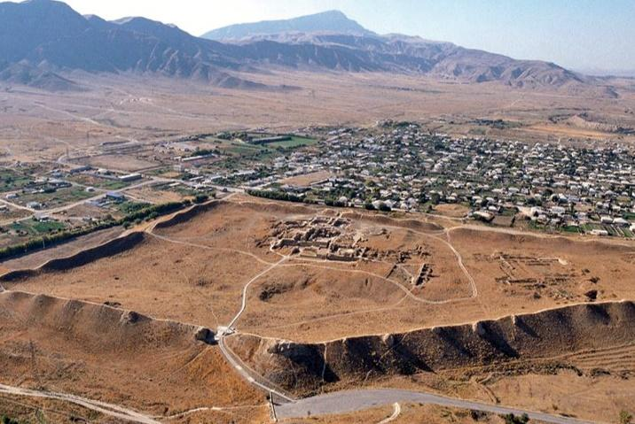
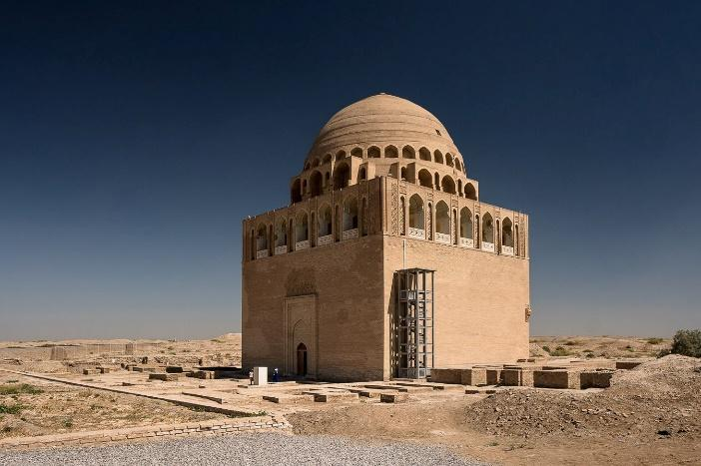
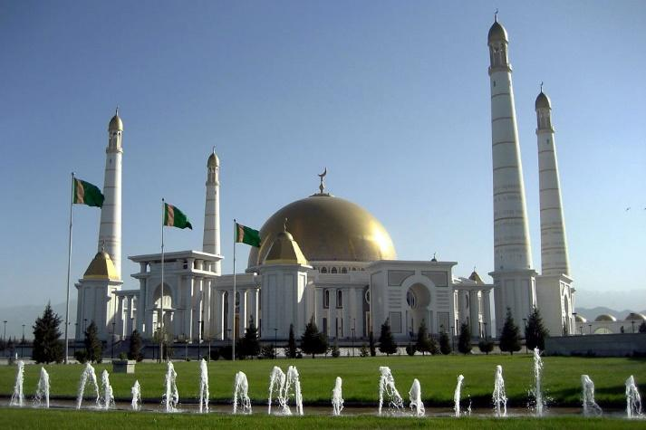

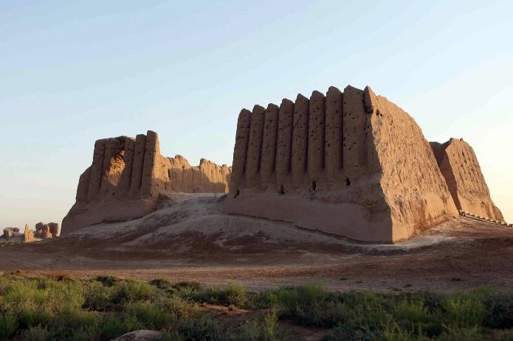

Notes:
• The price is based on an individual tour arrangement.
• The itinerary may be adjusted depending on domestic flight schedules, weather conditions, and road conditions.
• Accommodation in the Darvaza area is simple and is provided in tents or yurt-style desert camp conditions.
• This itinerary combines long overland journeys with remote archaeological and natural sites, allowing travelers to experience the full diversity of Turkmenistan.

